**District Prayer Encounter – August 2-3, 2012**

**Springfield First Church of the Nazarene**

Speakers: Rev. Corey Jones and Rev. Maria Durso

Worship Leader: Rev. Gregg Sowards

Day Sessions: 9:30 a.m. to 4:30 p.m.

Evening Sessions: 7:00 to 9:00 p.m.

***“The church always fails at the point of self-confidence. . . . The root trouble is that the church has more faith in the world and the flesh than in the Holy Ghost. The church is powerless without the fire of the Holy Ghost. Destitute of fire, nothing else counts; possessing fire nothing else matters.”***

**--Samuel Chadwick, *The Way to Pentecost***

**Maria Durso:**

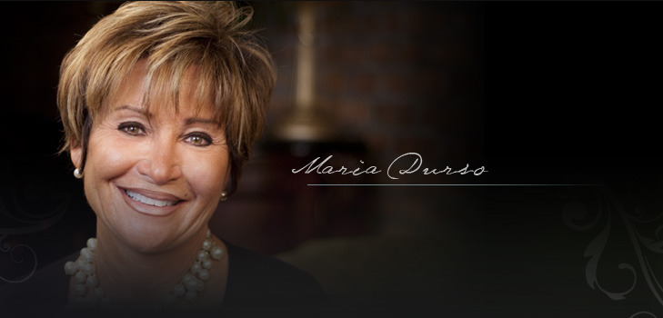 Maria and her husband Michael co-pastor at Christ Tabernacle, the first church to be birthed from the legendary Brooklyn Tabernacle in New York City where Jim Cymbala serves. God miraculously saved Maria from years of abuse and drugs, and has given her a ministry of intercessory prayer which encourages women through fellowship, worship and scripture. She has spoken at numerous Nazarene churches and at the Dallas District Assembly.

**Corey Jones:**

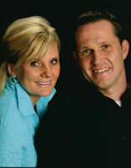Corey, pastor at Crossroads Tabernacle Church of the Nazarene in Forth Worth, TX, has been to our district several times for prayer encounters. A number of years ago Crossroads was ready to close. But at a Tuesday night prayer service God changed Corey’s heart with a vision for intercessory prayer. Please read his story at [www.ctgiveshope.com](http://www.ctgiveshope.com).

Registration Online:

Registration is done online at [www.illinoisnaz.org](http://www.illinoisnaz.org); follow the link to “prayer encounter”. Pre-registration is required for adults for day sessions at a cost of $10. *There is no charge for teens and college age students or for evening sessions.* Pay by check or cash at Springfield First. Motels are listed in a separate attachment.

**District Prayer Encounter – August 2-3, 2012**

**Springfield First Church of the Nazarene**

Speakers: Rev. Corey Jones and Rev. Maria Durso

Worship Leader: Rev. Gregg Sowards

Day Sessions: 9:30 a.m. to 4:30 p.m.

Evening Sessions: 7:00 to 9:00 p.m.

***“The church always fails at the point of self-confidence. . . . The root trouble is that the church has more faith in the world and the flesh than in the Holy Ghost. The church is powerless without the fire of the Holy Ghost. Destitute of fire, nothing else counts; possessing fire nothing else matters.”***

**--Samuel Chadwick, *The Way to Pentecost***

**Maria Durso:**

 Maria and her husband Michael co-pastor at Christ Tabernacle, the first church to be birthed from the legendary Brooklyn Tabernacle in New York City where Jim Cymbala serves. God miraculously saved Maria from years of abuse and drugs, and has given her a ministry of intercessory prayer which encourages women through fellowship, worship and scripture. She has spoken at numerous Nazarene churches and at the Dallas District Assembly.

**Corey Jones:**

Corey, pastor at Crossroads Tabernacle Church of the Nazarene in Forth Worth, TX, has been to our district several times for prayer encounters. A number of years ago Crossroads was ready to close. But at a Tuesday night prayer service God changed Corey’s heart with a vision for intercessory prayer. Please read his story at [www.ctgiveshope.com](http://www.ctgiveshope.com).

Registration Online:

Registration is done online at [www.illinoisnaz.org](http://www.illinoisnaz.org); follow the link to “prayer encounter”. Pre-registration is required for adults for day sessions at a cost of $10. *There is no charge for teens and college age students* *or for evening sessions.* Pay by check or cash at Springfield First. Motels are listed in a separate attachment.